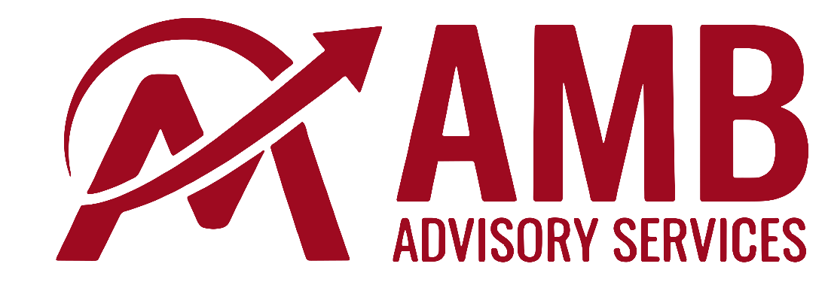

Initial Client Prospectus

Example Business Overview (“EBO”)
St. Louis, Missouri

Table of Contents

Table of Contents 2
Executive Summary 3
Business Overview 5
Financial Summary 6
Customers 8
Employees 9

Executive Summary

Business Overview
EBO is based in St. Louis, with offices in Columbia, Missouri and Chicago, Illinois. The company services 244 clients and 38K units, with 63 employees. EBO has a sizable maintenance business, representing over a third of total revenue. EBO is owned primarily by Bob and Jane, who each control 47.5% of the company. Their CFO, Bobbie, owns the remaining 5% and manages client accounting. The company earned $8.9M in Pro Forma Dec’24 revenue and $2.0M (27% margin) in Pro Forma Dec’24 EBITDA.

Key Statistics
$20M - $26M  Asking Price Range | $8.9M  PF Dec’24 Revenue | $2.0M  PF Dec’24 EBITDA | 10.0x – 13.0x  EBITDA Multiple Range
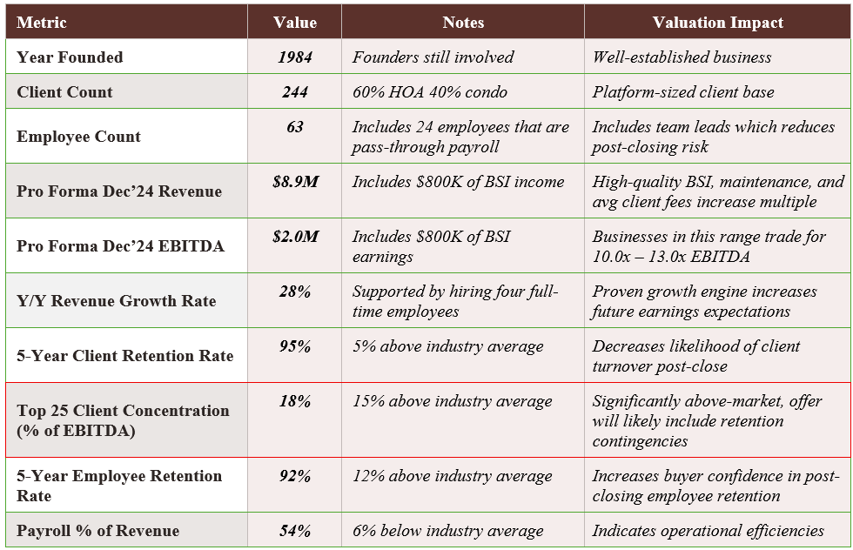
Key:
Positively impacts valuation | Negatively impacts valuation

Valuation & Structure Rationale
In the association management industry, EBO’s valuation would trade at 10.0x – 13.0x earnings based on the company’s $2M of PF Dec’24 EBITDA. EBO’s track record of client growth, client retention, employee retention, and staffing efficiency puts the company on the higher end of the valuation spectrum, implying a valuation of approximately $26M (13.0x multiple).
In terms of deal structure, EBO’s significant customer concentration will likely lead to an offer with contingent payments based on retaining specific clients for a period of time (likely 1 – 2 years) post close. Since both Bob and Jane would like to retire and currently work full-time as the CEO and CFO, buyers will likely request that they remain active for 6 – 18 months post-close as the buyer identifies, hires, and trains replacement executives to manage operations.

Recommended Offer Structure
Deal Term | Details
Asking Price | $26M
Valuation Multiple | 13.0x
Cash at Close | $21M (80% of valuation)
Seller Note | $5M, 18-month term, quarterly payments, 9.0% interest (20% of valuation)
Seller Note Contingencies | $1M reduction in seller note if Brentwood, Raintree, or Westport terminate service
Earnout (if applicable) | None
Seller Stay-On Agreement | One-year, full-time, $150K compensation
Employment Agreements | Likely with three Regional Managers
Working Capital | One month of payroll as reconciliation holdback
Asset vs. Stock Sale | Asset sale
Target Close Date | April 30, 2025

Reason for Sale
The two majority owners, Bob and Jane (47.5% each), would like to retire and transition out of the company after a year of transition support. Bobbie (5% ownership) would like to stay on and continue supporting the business. She is comfortable selling her minority interest in the company.

Business Overview

EBO Description
EBO was founded in 1984 by Jane and Bob and has grown to become one of the leading HOA and condominium management firms in the St. Louis metro area. The Company provides full-service association management to 244 communities across Missouri, including maintenance services.

Services Offered

Core Association Management Services
- Full-service HOA & condominium association management
- Board governance support and meeting facilitation
- Financial management: budgeting, accounts payable/receivable, reserve fund analysis
- Vendor management and contractor coordination
- Homeowner communications and portal management

Ancillary / Add-On Services
- In-house maintenance and repair coordination
- Transfer fee processing and resale document management
- Insurance certificate management
- Violation enforcement and compliance tracking

Service Area & Geography
Primary market: St. Louis Metro Area
Office location(s): 123 Blinded Office Blvd.
Remote / hybrid: Fully in-office

Software & Technology Stack
Client accounting: Vantaca
Corporate accounting: QuickBooks
Transfer & resales: CondoCerts
Payroll: Innovia
Client banking: First Citizens
Homeowner portal: Vantaca
CRM / Sales: N/A

Ownership Structure
Legal entity: LLC
State of formation: Missouri
Owner Name | Ownership % | Role | Post-Close Role
Bob | 47.5% | CEO | Retiring
Jane | 47.5% | CFO | Retiring
Bobbie | 5.0% | Head of Client Accounting | Head of Client Accounting

Financial Summary
Note: All figures in USD thousands unless noted. Financials are as provided by Seller and have not been independently audited.

Summary Income Statement
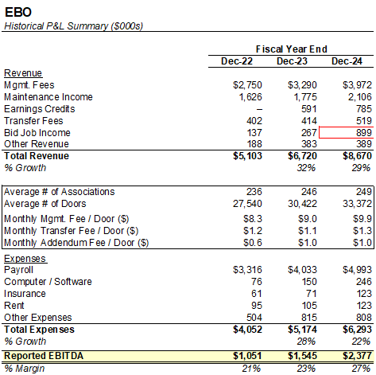

EBO is a high margin organization (27% margins) with 30% overall revenue generated from the company’s maintenance income. Profitability has been driven by excellent employee and customer retention, which has allowed for strong utilization and efficiency and lean support operations, particularly in accounting.
Bid job income tripled from ‘23 to ‘24, driven by a single large roof replacement project, and has reverted towards historical performance over the TTM period. The increase in earnings credit income was due to the timing of EBO’s earnings credit agreement with First Citizens beginning in May 2023. The agreement is a floating rate based on Fed Funds, and is similar with other agreements.
STL has grown faster than Columbia due to pricing competition in that market; EBO positions itself as a more premium provider, which has allowed for some undercutting.
Maintenance revenue growth has driven largely from the addition of several dedicated employees at EBO’s largest customer (and the largest Condo association in MO). This customer has also driven an uptick in bid job income due to a project to replace approximately 1,700 decks across the association. As of Q1’25, approximately 300 have been completed, and management estimates the project to continue for another ~3 years.

Reported EBITDA to Pro Forma EBIDA Bridge

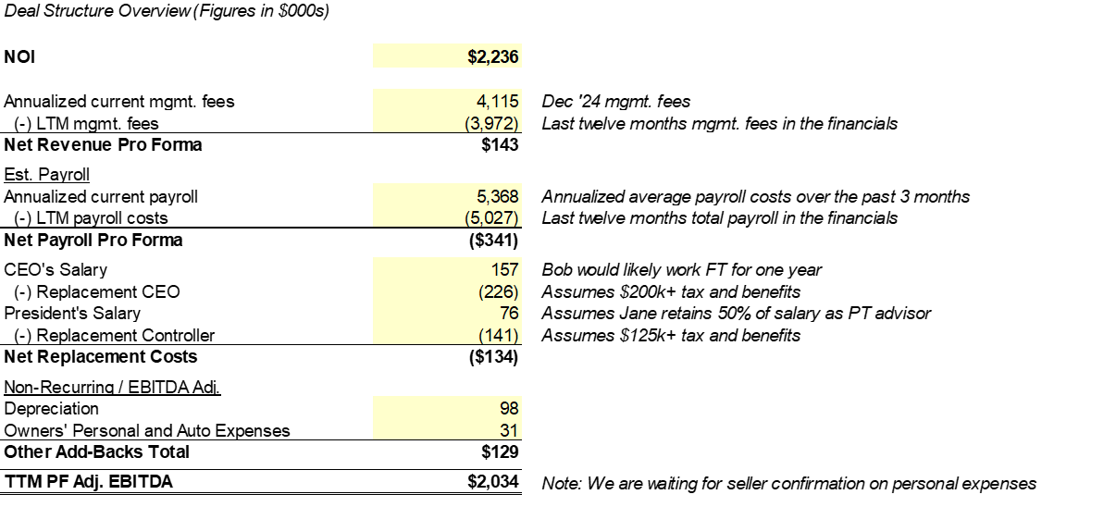
The PF EBITDA adjustment includes a significant increase in personnel costs, driven both by the replacement costs of new leadership as well as annualized payroll costs for new employees hired over the past year to support growth.

Bid Job Income Revenue

Bid job income spiked in 1Q24 due to a significant capital project engagement with Brentwood (the largest client). We will need to discuss the likelihood and frequency of these capital projects, along with the contribution margin to determine normalized bid job earnings (estimated $250K EBITDA impact).

Customers

Customer Concentration
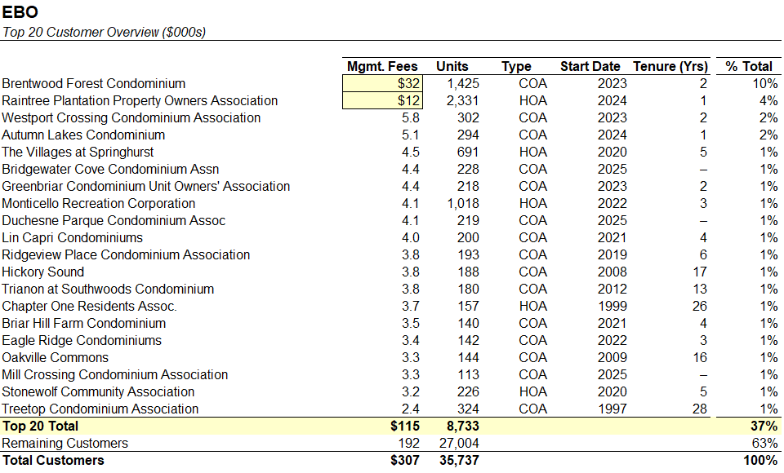
EBO’s largest customer is Brentwood Forest Condominiums, the largest condo complex in the state of Missouri. Brentwood has four dedicated onsite management personnel, three dedicated maintenance people, and is additionally in the midst of a significant capital improvement project being managed by EBO. Additionally, due to its size Brentwood averages ~$5M of deposits in bank accounts, which contributed meaningfully to earnings credit revenue. Given these diverse revenue streams, we estimate that Brentwood makes up 15-20% of overall earnings.
The customer relationship with Brentwood is strong, and Brentwood preemptively reached out to renew the contract and negotiations are ongoing. However, Brentwood is also going through a board election within the next month.

Client Retention Analysis

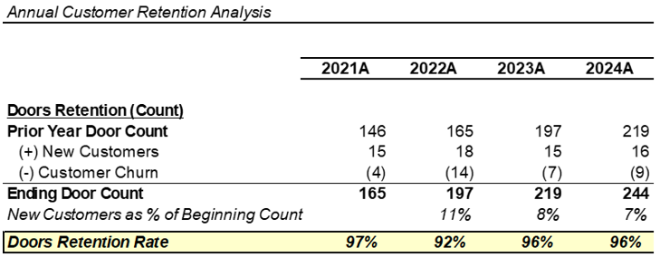

Employees

Employee Overview
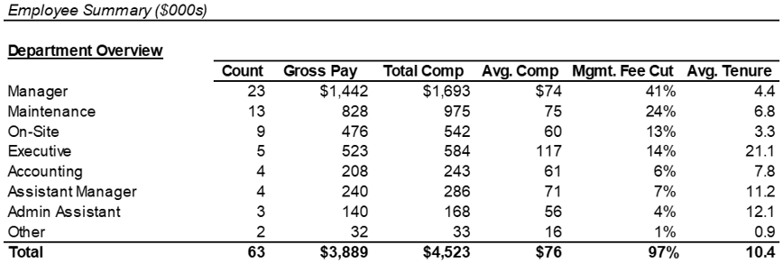
EBO operates with a CAM cut and mgmt. fee cut in-line with industry expectations. The company noted that all but one manager currently has capacity to take additional accounts, and no additional managers are needed for the foreseeable future.

Organizational Structure
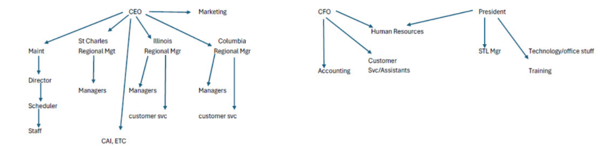
EBO has a strong leadership organization beneath the three sellers. Bob oversees the leader of the maintenance organization and regional market heads for St. Charles, Illinois, and Columbia. The market heads support his marketing and business development efforts in their territories, with the St. Charles lead supporting marketing across the entire organization.

Employee Retention Analysis
